**TASK 01**

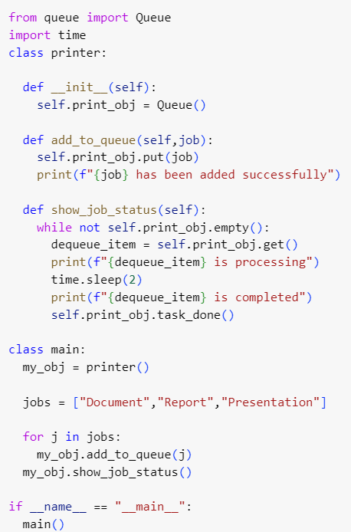

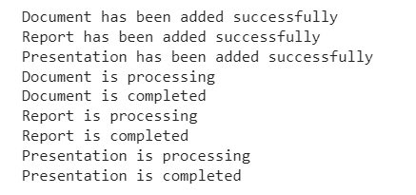

**TASK 02**

**TASK 03**



